How to Upgrade Device
First you should open UpgradeTool file path, double click the UpgradeTool.exe.

It will show like this:
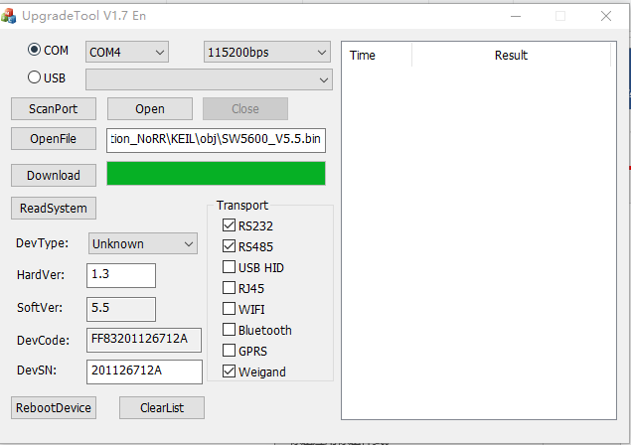
The soft support Com and USB interface. (Warning, some device only can use COM ( Serial port) upgrade because no USB interface.
The first step:
Power on the device , then connect device’ COM or USB interface to PC.
Click ScanPort button, 

It can auto scan the PC COM list and USB device List.
Then choose the right COM or USB, if you use COM, you should select like this, . If you use USB, you should select USB.
If you select COM, select the correct COM port , such as COM1, as same time select right baudrate, the defaute baudrate is 115200 bps, if upgrade fail, you should try other baudrate maybe you change the baudrate.
After select interface, click the OpenFile button

Then choose the upgrade file , .Bin file
Such as:
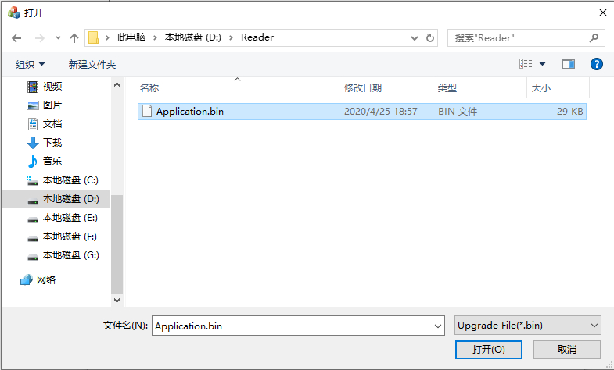
Then click Download button. 

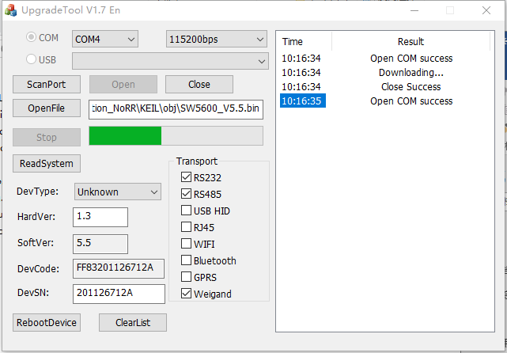
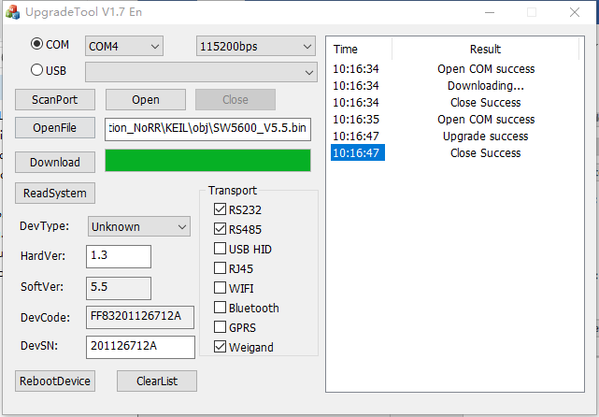
When the list information show Upgrade success mean upgrade success.
If show Upgrade failed, please check the Power and check the USB or COM wire, or Baudrate.

